**Code Switching and Code Mixing: A Sociolinguistic Study of Senegalese International Students in Iraqi Colleges**

**Qasim Obayes Al-Azzawi**

**University of Babylon/College of Education for Human Sciences**

**( [quda61@yahoo.com](mailto:quda61@yahoo.com))**

**Majid Mohammed Saadoon Hasan Hadi Mahdi**

**University of Kufa**

**m.arow1970@gmail.com hasanabukrooz82@yahoo.com)**

**Abstract**

The term 'code-switching' refers to the juxtaposition of elements from two (or more) languages or dialects. There is, however, little agreement among scholars on either the semantic scope of the term as they use it, or the nature of distinctions to be drawn between it and other, related terms such as code mixing. The term 'code-mixing' is a fluid one that overlaps with 'code-switching'. Switching and mixing may happen to a certain extent in speech of all two languages in a way that results in real confusion in relation to the two sociolinguistic terms. Thus, this work attempts to produce a rather comprehensive socio-linguistic approach to investigate these two distinct but interrelated sociolinguistic phenomena. This includes investigating the most observable operational definitions, distinguishing linguistic features and most influencing sociolinguistic factors on the use of the two terms. In light these aims the study hypothesizes that code- switching and code- mixing can be inspected from various viewpoints. Moreover, the processes of the code- switching and code- mixing and their linguistic aspects and performances are connected. To achieve the aims of this work and test its hypotheses, the most relevant definitions, distinctions and sociolinguistic issues are considered. Based on the findings of the analysis, the study concludes that: Both code switching and code mixing are used by Senegalese students who are studying Arabic in Iraq – Najaf due to the fact of multilingual students were exposed to four languages at a very early age in Senegal, particularly in school interactional settings. Employing certain language(s) in communicating with each other reflects several important vital factors that control their choice of language at any given situation. Switching to Wolof is always the case if one is talking to a fellow citizen. It is easier, clearer and reflects more seriousness too. Moreover, Wolof is used by them in order to show solidarity and intimacy as well as their group identity. In scientifically oriented discussions and exchanges French takes precedence. It’s the language at school, so it is the language of all scientific idioms and expressions.

**Keywords:**Code- Switching, Code- Mixing, Senegalese International Students, Mechanical Switching, Code Changing.

**الخلاصة**

يشيرمصطلح الإبتدال اللغوي إلى الجمع بين العناصر اللغوية من لغتين او لهجتين . لكن قلما يتفق اللغويون حول النطاق الدلالي أو ماهية المميزات التي تميزه عن غيره من المصطلحات التي ترتبط به مثل الامتزاج اللغوي الذي يتداخل من حيث الدلالة مع الإبتدال مسببا الإلتباس في فهم المصطلحين .لذا تحاول هذه الدراسة التأسيس لمدخل لغوي اجتماعي صرف لدراسة هاتين الظاهرتين. وبموجبه تحاول الدراسة تحديد التعاريف الاكثر قبولا والخواص والشروط والعوامل الاجتماعي-لغوية التي يتم إستخدام كل من المصطلحين بموجبها ولتحقيق اهداف البحث واختبار صحة فرضياته يستعرض البحث التعاريف والخواص المميزة والمسائل الاجتماعي-لغوية المؤثرة في استعمال هذين المصطلحين. وعطفا على النتائج التي افرزها التحليل توصل البحث إلى إن الطلبة السنغاليين الأجانب يوظفون الإبتدال اللغوي و الامتزاج اللغوي بسبب تواصلهم بواسطة اربع لغات في بلدهم الام .

**الكلمات المفتاحية**: الإبتدال اللغوي، الإمتزاج اللغوي ،الطلبة السنغاليين الأجانب ، الإبتدال الآلي ، التغير اللغوي.

**1.Introduction**

In inspecting in the way of research of the code change it has appeared that code- switching and code- mixing can be inspected from various viewpoints. The concentration of scholars on code change after they had understood that linguistic aspects and performances are connected . And code – mixing /- switching , also, incorporates not just alteration, but a relation between linguistic aspects and language use as social phenomenon . Research from a linguistic and psycholinguistic viewpoint has concentrated on knowing the characteristics of code – change as a method of realizing linguistics and possible cognitive processes. Research on social and psychological proportions of code – mixing/ switching has largely been dedicated to know the answer of questions of why speakers of code – change and what is the social meaning of code change is for them. The sociological viewpoint later tries to apply the answers to those questions to illustrate how language works as social phenomenon.

The historical background of research on code – mixing/ switching it has been suggested that it is substantial to connect all these forms of analysis and that, in fact, it is that potential that is one the most compulsory causes for surveying code – mixing/switching , since this connection would allow the evolution and consummation of hypotheses concerning the relation among linguistic , cognitive and social processes in a more general way (Heller and Pfaff 1996:100).

**1.2 Code- Mixing Code-Switching Terms in Sociolinguistics**

According to Meyerhoff (2006:115-116) people of bilingual , or who have the ability to speak more than one variety of any language , are mostly quite responsive to the variations in the liveliness of the languages they speak and they are evenly conscious that in some positions one aspect of variety will avail their wants better than the other. So for speech of language that extract to variety scope of nearly two languages linked in various ways , as when Malay /English bilingual says : this morning I hantar *my baby tu dekat babysitter tu lah* (*hantar took*, *tu dekat to* the, *lah* a particle marking solidarity). A code may be a language or a variety or style of a language ;the term code-mixing confirms hybridization , and the term code-switching confirms the movement from one language to the other. Switching and mixing may happen to a certain extent in speech of all two languages people , so that there is a feeling in which a speaker has the ability to speak two languages .

**2. Definitional Issues**

As with any aspect of language contact phenomena, researches on code- switching and code-mixing are firstly afflicted by the matter of confusion concerning the these terms.

**2.1 Definition of Code**

In conversations , a code is a rule for converting a part of datum (e.g. a letter, word , or phrase to the other aspect or representation , not exactly the same kind. In conversations and information processing , encoding is the method by which a source (object ) acts in this change of information into data , which is then sent to a listener (receiver) like a data processing system (Mesthrie , 2001: 55).

In semiotics, the concept of ‘code’ is of essential value . De Saussure confirmed that signs just have meaning and value when they are realized in connection of one to another . He believed that the relationship between the signifier and signified was arbitrary . Hence, interpreting signs requires awareness with the set of conventions or codes presently in employment to transfer meaning (Trask and Stockwell, 2005:40).

In computer programming, the word code denotes to directives to a computer in a programming language. Concerning this case, the noun "code" normally refers to source code, and the verb "to code" refers to write source code, to program. This usage may have derived from the first symbolic languages were advanced and were swiped onto cards as "codes”.

The concept **code** is relatively indifferent conception of a linguistic sort_ it is a language or a dialect. Romaine (1995: 33) mentions that: “I will apply the term ‘code’ here in a general significance to denote not just to various languages, but also to variations of the same language as well as styles within a language.” Though, not many scholars indeed illustrate the concept in their definition. In this research, *code* will be subscribing as an actual component that can be as small as a morpheme or as overall and complex as the complete system of language.

Crystal (2008: 83) says that the common significance of this concept – a variety of conventions for transferring one signaling system into another – inscribe to the subject of semiotics and communication theory rather than linguistics. These terms as ‘encoding’ and ‘decoding’ are occasionally confront in phonetics and linguistics, but the vision of language as a ‘code’ is not one which sets greatly in these subjects. The concept has presented to the former in sociolinguistics, where it is at most applied as an indifferent name for any system of interaction concerning language – and which averts sociolinguists having to involve themselves to this terms as dialect, language or variety, which have a specific matter in their theories.

Nevertheless, lots of sociologists and sociolinguists have put ‘code’ in a more limited definition. For instance , codes are occasionally illustrated in terms of reciprocal intelligibility (e.g. the language of a private or professional group). But the most common specific usage of the concept was in the theory of communication codes presented by the British sociologist Basil Bernstein (1924–2000). His distinction between detailed and confined codes was an aspect of a theory of the grain of social systems, concerned specifically with the kinds of references people communicate, and how clearly they do this, applying the field of resources provided by the language.

**2.2 Difference between Code-switching and Code-mixing**

Many researchers have tried to define code-switching and code-mixing. Among them are Halliday (1978), Atoye (1994) and Muysken (2000). For instance, Hymes (1978: ) defines only code-switching as “a popular concept for substantial usage of two or more languages, diversities of a language or even speech styles. “while Bokamba (1989: 281) appointed both terms thus: “Code-switching is the blending of words, phrases and sentences from two different grammatical (sub)systems onto sentence limits within the same speech session … code-mixing is the installing of different linguistic units such as affixes (bound morphemes), words (free morphemes), clauses and phrases from a mutual event where the speakers, in order to denote what is meant, must coincide what they hear with what they realize. “

Code switching is not an exhibit of imperfect language knowledge: a grammarless blending of two languages. Instead it is a phenomenon in which its speakers speak a scope of meanings. By code switching, which happens generally in a dialogue, the option of speech exhorts the speakers to the conversation of the context and social proportion in which the interaction is happening. The event of code switching is inspected from a perspective of conversation analysis, and as such is noticed as reactive turns among participants of two languages speech community.

Frequently the concept code mixing is applied as equivalent with code switching and denotes substantially intra-sentential code switching. Though, last survey has shown new denotation to this concept . Maschler (1998: 125) shows that code mixing or a mixed code as “speaking two languages and then a third, new code appears, in which different aspects of the two languages are incorporated into a structurally assignable pattern”. In other words, the code mixing hypothesis presents that when two code switched languages comprise the emergence of a third code it has structural features specific to this new code.

In addition to that , Meyerhoff (2006:115-116) says that code mixing " mostly points to shifting between choices , or codes, within a phrase or clause. It frequently evolves mostly negative estimations than variations or code switching onto clauses.

**2.3 Types of Code- switching and Code- mixing**

There are various types of code-switching. Code-switching can be either inter-sentential, intra-sentential or Tag- switching. In inter-sentential code-switching, the language switch is happened at sentence limits. This occurs frequently among fluent bilingual users. Sometimes I will begin a sentence in English( y terminό in español). (Poplack, 1980: 58)

In intra-sentential code-switching, the change is happened in the mid of a sentence, with no obstructions, hesitations, or pauses recognizing a switch. This always happens within one sentence or even a one phrase. The bilingual is always insensible of the shift, until after the fact, and for example, you have to find a kalo pedi (good guy) and marry him. (English-Greek)

The first kind of language switching is called as mechanical switching. It happens unconsciously, and fills in unfamiliar or unavailable concepts in one language. This type of code-switching is also called as code-mixing. Code-mixing happens when a bilingual is rapidly unable to recall a concept, but is capable to remember it in another language.

A second kind of code switching, called as code-changing, is described by eloquent intra-sentential changes, shifting concentrates from one language to another. It is stimulated by positional and stylistic reasons, and the aware nature of the change between two languages is asserted (Lipski, 1985: 12).

The third kind of code-switching is Tag- switching. This demanded the interpolation of a tag in one language into an utterance that is moreover entirely in the other language. There is example, so he asked me for money, znas #, I had to say no, znas #. The tag here is Serbian for ‘you know’.

Code-mixing is one of the main types of language variety which is accurate than ‘code- switching’, as mentioned by Fasold (1984: 66). In code-mixed sentences, parts of the one language are applied while a bilingual is essentially using another language.

The kinds of code switching have been examined up till this stage show the option between languages or varieties as being something like an ‘either–or’ question. Either the conversation occurs in Rangi, or it occurs in Swahili. Either it is in Pidgin or it is in English. In practice, there can be a lot of mixing of codes within a single turn-taking or even within a single participant’s turn. If researchers want to, there will more to talk about changes during turns as **code mixing**, but not all investigators realize the ways marking switches during turns and among different communicational incidents are adequately diverse to justification totally separate terminology.

It is clear that the types of interpersonal or influential duties linked with the usage of Pidgin in Hawai’i or use of Rangi in Kondoa also act as part in switching within turns. So there are mingled codes which indicate in-group mood and impact. On the contrary, they are able to show animosity to strangers who may not realize all the mixed constituents or may not realize the customs controlling how the codes are mingled. Miki Makihara’s work on Rapa Nui (Easter Island) disputes the way in which a mixed code has been creating there since the 1970s or 1980s. This home-grown interactional code is now used by children and adults alike. It comprises immense mixing of Rapa Nui (a Polynesian language) and Spanish (Rapa Nui is administered as part of Chile, so both Chilean Spanish and a Rapa Nui variety of Spanish are used in Rapa Nui). Makihara thinks that this mixed variety works as an significant indication of an created sense of Rapa Nui solidarity and identity, and perhaps first appeared in informal conversations; Makihara also discusses the social functions it seems to index within informal conversations.

**3. Overall Analysis and Results**

This paper in intended to study the code switching case used by a group of students from Senegal who are studying Arabic in Iraq - Najaf. The reason why they were chosen is the fact that these students were exposed to four languages at a very early age in Senegal. This paper aims to reveal the reasons controlling their language of choice at any given situation through asking them a number of questions about their linguistic behavior there and here.

**3.1 Discussion and Results**

The first question was about the language Senegalese international students used to study with in their country? Their answers ( as illustrated in **Figure** (1) ) showed that almost 90% of them studied in French and Arabic while the rest 10% Studied in English. That shows French and Arabic as formal languages since they are almost always related to school settings.

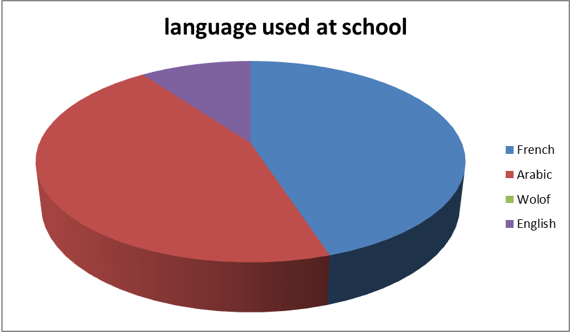

**Figure (1) Formal Languages Used at School**

The second question was about the language they use when they talk to their teachers in Senegal (See **Figure** (2). French came first with about 48% of them using it to communicate with the teachers while45% of them use Arabic and only 7% use their mother language (Wolof). Their choices showed that French is seen as a little more formal than Arabic as it was used more frequently to interact with the teachers.

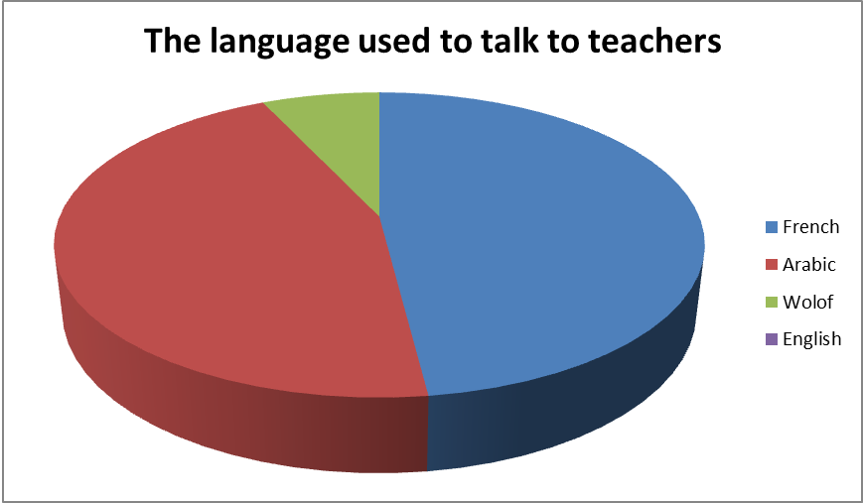

**Figure (2) Languages Used at School in Interaction**

The third question was about the language they prefer to use as they talk to each other inside school. 45% of them said they use French while 40% used their mother tongue and only 15% used Arabic. These results ( displayed in **Figure** (3))showed that Arabic is not much of an intimacy language for them. It is formal and used in formal settings most of the time.

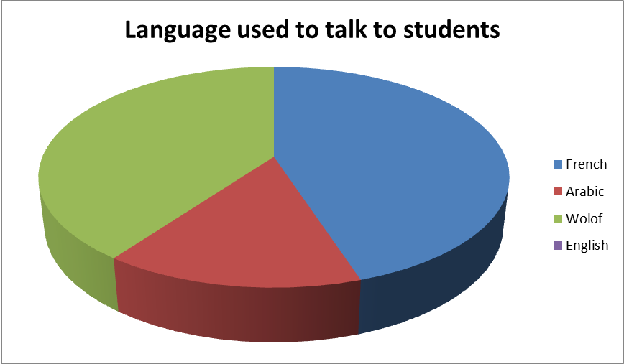

**Figure (3) Languages Used at School in Interacting with other Students**

The fourth question was about the language they use at home and in family settings. As expected, Wolof came first with about 90% users while 10% said that they might use French too. This shows that even though these students were exposed to more than one language at an early age, the mother tongue stays the most dominant one in all home and family settings. Figure (4) below illustrates this very significant result.

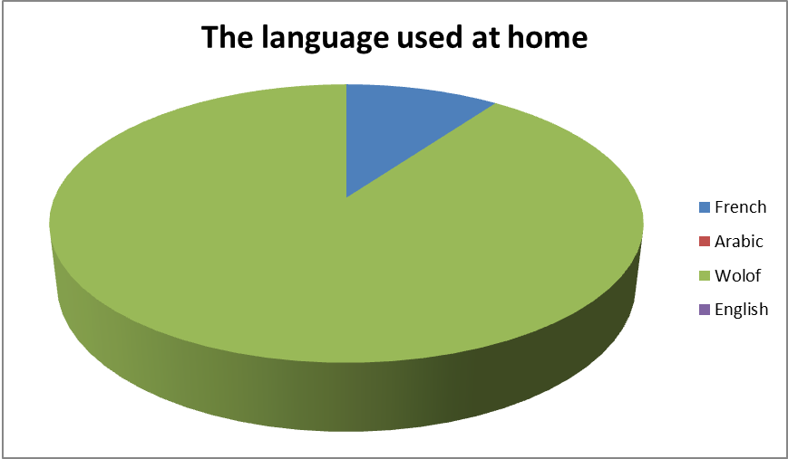

**Figure (4) Languages Used in Family Interaction**

The fifth question was asked about the language they use in the streets and on the market. Most of them still prefer their mother language (about 70%). The rest were switching between Wolof and French. Arabic and English are not likely to be used in these places.

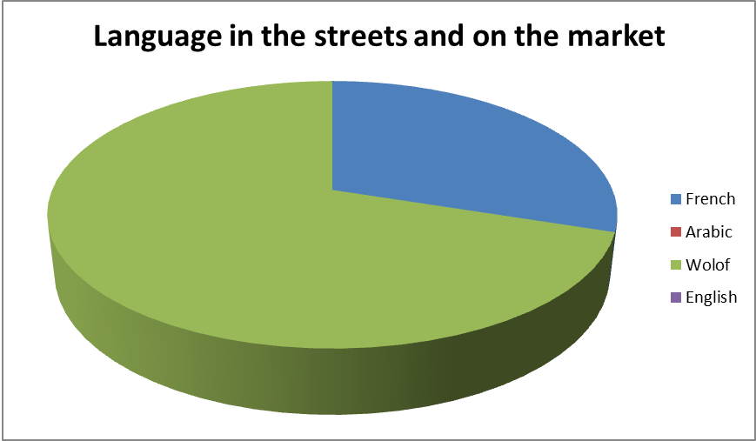

**Figure (5) Languages Used in Daily Face-to-Face Interactions**

**3.2 Discussion and Results of Iraqi Setting of Interactions**

With this background knowledge we got about the linguistic behavior of these students back home, a new set of questions was dedicated to study the effects of that behavior on them now as they study Arabic Language in the University of Kufa – College of Arts in Iraq.

The first question was about the Language they use when they speak with each other here in Iraq. Their language choices varied along with their reasons to use them.

Wolof and French : About 65% of them said they use Wolof language because it's their mother language and they are quite used to it. Another reason to use it is that they feel like they are going to forget it if they don’t run their conversations with it. Some of them added that the way they feel when they speak Wolof is unmatchable and their words can't feel as catchy or affective in any other language as they do in Wolof. As for French, 25% of them use it for the same first two reasons mentioned above.

Arabic and English: the case with Arabic is different. 7% of these students tend to use it not only with Arabs but also with each other because they feel like using it due to social interactions. Moreover, practicing Arabic is a part of their study ant it helps them improving their communicative skills. For 3% students, English is used for the same improving purposes.

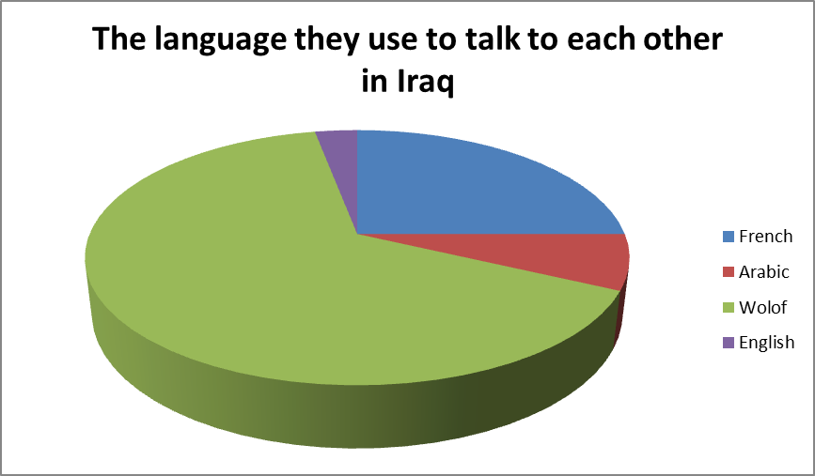

**Figure (6) Languages Used in Daily Face-to-Face Interactions in Iraq**

Question two was about their language of choice as they do the code mixing: what makes them choose one language rather than another at specific situations? Their answers showed that the reason why they pick a language to switch to depends on the language itself.

According to them, switching to:

1. Wolof: switching to Wolof is always the case if one is talking to a fellow citizen. It is easier, clearer and reflects more seriousness too.
2. French:

* switching to French comes generally with academic or scientific conversations. It’s the language at school, so it is the language of all scientific idioms and expressions.
* Conversations that include people from different social ranks bring about code switching too because French in Senegal is the language of the educated elite. That means it will be a good idea to switch to French in such situations.

1. **Arabic**:

* all the students said that choosing Arabic comes when they talk to Arab students.
* They also use Arabic to practice it because they are studying Arabic language these days.

1. English: only the students who studied English in Senegal like to use it here:

* when they talk to Arab students because English is a part of school curriculum in Iraq.
* To help themselves not to forget it.

**4. Conclusions**

On the basis OF the procedures followed by this paper and in compliance with the results and findings arrived at, the following conclusions can be introduced:

1. Both code switching and code mixing are used by a group of students from Senegal who are studying Arabic in Iraq – Najaf. However, this kind of multilingualism employed here is due to the fact that these students were exposed to four languages at a very early age in Senegal, particularly in school interactional settings.
2. Employing certain language(s) in communicating with each other reflects several important vital factors that control their choice of language at any given situation.
3. Switching to Wolof is always the case if one is talking to a fellow citizen. It is easier, clearer and reflects more seriousness too. Moreover, Wolof is used by them in order to show solidarity and intimacy as well as their group identity.
4. In scientifically oriented discussions and exchanges French takes precedence. It’s the language at school, so it is the language of all scientific idioms and expressions. That is why French is exploited in their academic collegiate stetting whether back home in Senegal or within the IRAQI educational environment in which these international student are present.
5. Conversations that include people from different social ranks bring about code switching too because French in Senegal is the language of the educated elite. That means it will be a good idea to switch to French in such situations.
6. Switching into Arabic is the result of their need to talk to Arab students. They also use Arabic to practice it because they are studying Arabic language these days. Thus, exploiting Arabic is part of their indulgence within their foreign setting of study. It is a kind of accommodation strategy employed by the students.
7. English also comes under the adaptation strategic uses especially within the Iraqi situation. Therefore, only the students who studied English in Senegal like to use it here: when they talk to Arab students because English is a part of school curriculum in Iraq. To help themselves not to forget it and to communicate in a rather friendly tone with their fellow Iraqi colleagues who are more familiar with English language.

**References**

Bokamba, E. G. (1989). Are there syntactic constraints on codemixing? In **World Englishes** Vol.8: Pp. 277-92.

Crystal, D. (2008).**A Dictionary of Linguistics and Phonetics (6thed.).** Oxford: Blackwell Publishing Ltd.

Fasold, R. (1984). **The Sociolinguistics of Society***.* Oxford, UK:

Blackwell.

Halliday, M.A.K. (1978).**Language as Social Semiotic: The Social Interpretation of Language and Meaning.** London: Edward Arnold Publishing.

Lipski, J. (1985). Code-switching and the problem of bilingual

competence. In: Paradis, M (ed.) **Aspects of Bilingualism**. Columbia, SC: Hornbeam Press.

Mesthrie ,R. (2001). **Concise Encyclopedia of Sociolinguistics**. Oxford: Elsevier Science Ltd.

Meyerhoff, M. (2006). **Introducing Sociolinguistics**. London and New York: Routledge Publishing.

Muysken, P. (2000) **Bilingual Speech: A Typology of Code-mixing***.* Cambridge. UK: Cambridge University Press.

Poplack, S. (1980). 'Sometimes I'll start a sentence in Spanish y termino en Espanol': Toward a typology of code-switching.In **Linguistics** 18**:** 581-618.

Romaine, S. (1995). **Bilingualism***.* Oxford, UK: Blackwell Publishing.

Trask, R.L. and Stockwell, P. (2005). **Key Concepts in Language and Linguistics**. Oxon: Routledge Publishing.