Design of prediction system for aircraft's position based on inverse control technique using Adaptive Neuro-Fuzzy Interference System (ANFIS)

**Mithaq Nama Raheema**

*Prosthetics and Orthotics Engineering Department, University of Karbala, Karbala, Iraq*

[*mithaqnama76@yahoo.com*](mailto:mithaqnama76@yahoo.com)

**Ahmad Shaker Abdullah**

*Computer Techniques Engineering Department, Alsafwa University College, Karbala, Iraq*

[*ahmedalsaadi199@gmail.com*](mailto:ahmedalsaadi199@gmail.com)

|  |
| --- |
| **ARTICLE INFO** |
| **Submission date**: 9/8/2018 |
| **Acceptance date**:16/10/2018 |
| **Publication date**: 10/3/2019 |

**Abstract**

This paper proposes the Adaptive Neuro-Fuzzy Interference System (ANFIS) method to realize the track correlation of Radar. ANFIS is used for the first time in inverse model in addition to model of aircraft position radar from the recorded data. The simulation results show that the proposed ANFIS controller has been successfully implemented. Root mean square error is applied to measure the performance of ANFIS that revealed the optimal setting needed for better estimation of the aircraft position. Results with RMSE less than 10-4 also show that the controller with ANFIS yields good tracking performance, valuable and easy to implement.

**Keywords** - ANFIS, Inverse Control, Kalman Filter, Radar

1. **Introduction**

The growing demand for security of cargoes and passenger of multiple of aircrafts nowadays, the performance improvement problem of conventional airport control systems must be faced. In recent years researches are focused on the development of integrated system, which getting information from different sensors, and distribute it to moving vehicles and to ground air-traffic controllers [1].

Radar tracking systems are dynamic and complex with both computing resources and radar being shared by many tasks with vastly varying requirements. Handling these tasks is a hard challenge to get the maximum benefit from the available resources. The factors of environmental such as heating constraints and the noise of the radar, distance, speed and maneuverability of tracked objects dynamically affect the mapping between resource requirements and the level of service [2].

The Kalman filtering is one famous approach for trajectory predication, which has been vastly used for predicting the direction of the ships, airplanes, satellites, etc. The Kalman filtering for unknown, noisy environments may not be convenient. To tackle the situation aforementioned, researches have been dedicated to build mathematical models, perform statistical data analysis, and make the Kalman filter more adaptive. As all alternatives, the learning mechanism has been used to assist the Kalman filter, since it is model-free and computational efficient after training [3].

The most applied learning methods are the intelligent methods such as Neural Networks (NNs) and Fuzzy Logic Systems (FLSs). The main advantages of these ways are its ability to learn and good efficiency for nonlinear functions approximation. In this work, we propose using the Adaptive Neuro-Fuzzy Interference System (ANFIS) to develop the intelligent radar predictor instead of Kalman filter.

1. **Radio Detection And Ranging (Radar)**

Radar system is used for tracking and detecting a variety of applications such as the weather systems, ships, and aircraft. Radar systems use directional antennas and modulated waveforms to transmit electromagnetic energy into a particular volume in space to search for objects. Targets will reflect parts of this energy within a search volume back to the radar. Then the radar receiver processed these echoes to extract object information such as angular position, velocity, range, and other object identifying characteristics [4].

There are two types of radar signals: a) pulsed, where a sequence of pulses of radio frequency (RF) energy that radar transmits. b) Continuous wave (CW), where the radar transmits a continuous signal. Radar can be classified as two types: monocratic and biostatic. The transmitter and receiver are collocated in monocratic radar; while the transmitter is separated from the receiver in biostatic radar, often by very large distances. The maximum object distance that the radar can detect is the Radar range. The target range (*R*) is determined for the given pulse by observing the time delay (*δ*) this pulse takes to travel the path between the radar and the object (two-way path). It is given by [5]:

 (1)

Where *c* = 3 × 108 m/s is the light speed

1. **Adaptive Neuro-Fuzzy Interference System**

Adaptive Neuro-Fuzzy Interference System (ANFIS) is formed from combination NN and FLS. This collection gives advantages of these two intelligent systems. Three models from this association can be categorized: concurrent model, cooperative model and fully fused model. The ANFIS used in this work is a common type of fully fused model [6].

The mechanism of ANFIS, in typical form, is with one output and two input and IF-THEN commonly used Sugeno rule as in Equation (2) [6], [7], [8]:



Where: and  are variables of input, and are sets of fuzzy, is the output, j is the number of rules, and $k$ is the parameter of consequent. Typically, the architecture of ANFIS is consisting of five layers with different functions supplements each other as shown in Figure1:

Fuzzification layer (Layer No. 1): The MFs are generated is this layer, Gaussian MF (as an example) is represented in Equation (3):



Where $O_{i}$ is the output of layer No. 1, $μ$ is the chosen membership function, is a linguistic variable of the ith input node, x is the ith node input, *di* is the center of the Gaussian function, and 𝜎*i*  is the Gaussian function width.

Rules layer (Layer No. 2): All outputs of layer No. 1 will be product here in operation called the firing strengths:



Where 𝑤𝑖 is the layer No.2 output rules.

Normalization layer (Layer No. 3): in which the MFs are normalized:



Defuzzification layer (Layer No. 4): in which the weighted resultant parameters of rules are calculated:



Where *ai*, *bi*, and *ci* are the MFs parameters.

Summation layer (Layer No. 5): In this Layer total ANFIS output, *f*, is calculated:



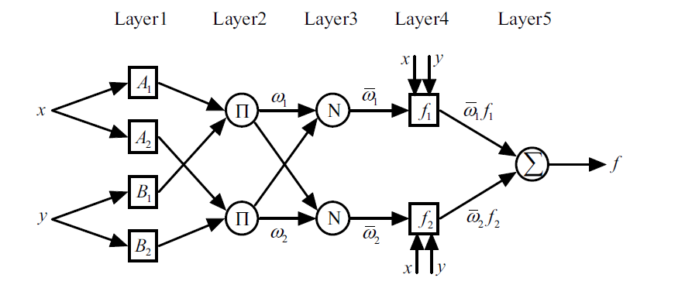

Figure 1 The general structure of ANFIS

1. **Inverse Control**

Getting the inversion of a nonlinear system is the significant challenge in the inverse control design. It has a lot of difficulties when using analytical methods. So with their ability of nonlinear approximation the intelligent algorithms can be used to find the inversion model [9].

Neural and fuzzy intelligent networks are used profusely in the identification, inverse modeling, and design of controller which are the main stages in the inverse control implementation for any unknown complex nonlinear system. Approximation of the considered plant under control then train an intelligent network with measured and reference signals as input-output training data are the steps of determining the desired signal of the system under control [10].

There are two methods of the inverse model controller for time dependent dynamic system: (a) Inverse control with online adaptive learning methods and (b) method of direct inverse control [10].

1. **Inverse control with online adaptive learning**

Adaptive system based on inverse control, shown in Figure 2, can be designed in two parts: (a) inhibition of noise in plant, and (b) control part for the dynamic response of plant.

The main idea of adaptive inverse control process is by send the output of the inverse model of the plant (object), which works as the controller, to drive this object [6].

Equation (8) represents the transfer function of this system from the inputs of the plant with disturbance to its output:



Whereis the plant (Object), and and are the model and the inverse model of plant respectively.

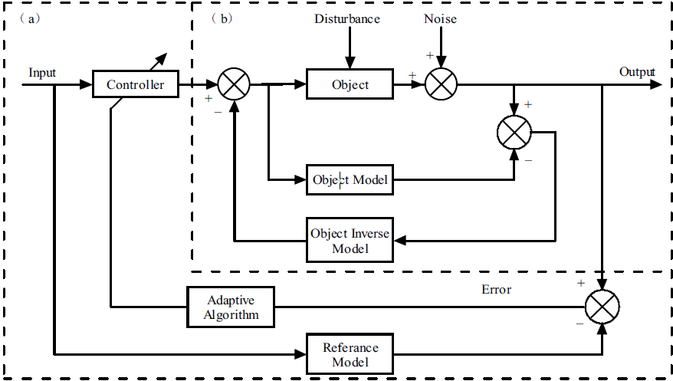

Figure 2 the structure system of adaptive inverse control [6]

1. **Direct inverse control**

Inverse model is used directly to control the system as shown in Figure 3. It's an input-output dynamic process is as represented in Equations (9) and (10) [11]:





Where  and  are the values of input and output at ith time respectively.



Figure 3 structure of the direct inversecontrol

In this work, the proposed ANFIS control system can be classified as a direct inverse control model.

1. **Simulations and Results**

Simulation is carried out the ANFIS system with offline trajectory data. Trajectory data are taken from Matlab toolbox after simulating the Aircraft Position Radar Model (APRM). The APRM model contains an Extended Kalman Filter that estimates aircraft position from radar measurements.

In the simulation process the initial conditions are fetching the two values of input and output for both North-South (N-S) and East-West (E-W) positions. The total number of data used is 100 points for each axis, 70 points of the data are used in training process and other data are used for testing. Then the parameters for training the ANFIS are set as: initial step-size is 0.01, number of training epochs is equal to 1, and the increase rate of step-size is 1.5, while the step-size decrease rate is equal to 0.5and a Gaussian membership used. The training process is performed using Matlab 2014a.

To improve the performance of the proposed system, some of process are used in the presented controller design such as setting the same value of ANFIS parameters for both identification (model and inverse model); or set each identification process with different values of parameters according to the input-output training data. Third process is the normalization of the training data and finally the scaling step by gain the actual output value in order to fit the reference signal.

The first process is the selection of training signals as inputs and determining the input parameters for an ANFIS.

Selection of these inputs can be done by many different methods such as the intensive computational method in which all the candidates input will be searched as potential combinations. There is another method called the sequential forward in which the total error is optimized by sequential chosen for all inputs.

To predict value of output y (j), at time u (j), let the number of input candidates are available as enough as, for example 10 parameters, and these input-output data are formed as:





The first intensive search method is used in this work by applying Equations (11) and (12) on the available input candidates, to choose three input parameters as a result: one from input data and the other two are from output data:

and  are the selected input to ANFIS for N-S position, whileand are selected input to ANFIS for E-W position. The designed system of radar tracker is shown in Figure4, and Figure5 show the system diagram of ANFIS which contains one output and three input parameters that required 8 rules in the fuzzy inference of type Takagi-Sugeno.



Figure 4 The system proposed of radar tracker identifiation



Figure 5 The system diagram of ANFIS

Figure 6 and Figure 7 show the normalized input and output data of aircraft position radar system under the test of simulation for N-S position and E-W position respectively. These data are used for training.

|  |  |
| --- | --- |
| Figure 6 input and output data of aircraft position radar system in N-S position | Figure 7 input and output data of aircraft position radar system inE-W position |

To find the inverse model, the first step is exchange the input data with the output data, thereafter train the ANFIS to finds the inverses identification modeling of the aircraft system. Figure 8 and Figure 9 show the training and checking results of ANFIS for both two positions with RMSE is 0.00014515 for training and checking of N-S position, while 5.2635e-05 is RMSE value for training and checking for E-W position.

|  |  |
| --- | --- |
| Figure 8 checkinand training results with ANFIS prediction of inverse modeling of N-S position | Figure 9 checkingand training results with ANFIS prediction of inverse modeling of E-W position |

These Figures show the capability of the ANFIS networks to predict the aircraft system in training and checking operation with minimum root mean square error.

Then put back the main inputs-outputs data to find the modeling of the original system of aircraft. Figure 10 and Figure 11show the results of ANFIS modeling systems with 0.0027986 RMSE for training and checking for N-S position, while the RMSE of E-W position is equal to 0.00019486.

|  |  |
| --- | --- |
| Figure 10 simulation result using ANFIS for training and checking data of N-S position | Figure 11 simulation result using ANFIS for training and checking data of E-W position |

From Figures (8, 9, 10 and 11), the results of simulation process show that the ANFIS modeling has good performance, strong robustness with minimum error and fast position tracking capability.

Figure 12 shows the flowcharts of the ANFIS trainings and checking processes for the identifications step of this work.



Figure 12 The flowchat of ANFIS trainings and checking for identifications processes.

Figure 13 shows the overall construction of the proposed aircraft system control based on an inverse modeling design for aircraft position radar system.



Figure 13 proposed system of aircraft position radar system on inverse modeling design

Figure 14 show the results of testing with randomly chosen points of the system under control and it can be seen that's the actuals values are at most fits to the desired values.

Figure 15 displays the sorting RMSE to show the difference between the actual and desired outputs.

|  |
| --- |
| (a)(b)  Figure 14 the desired and actual output (a) N-S position (b) E-W position |

|  |
| --- |
| (a)(b)  Figure 15 sorting RMSE values (a) N-S position (b) E-W position |

1. **Conclusion**

In this paper the training process and effective design of an ANFIS controller based on model of inverse controller for nonlinear dynamical system is applied to valuate an aircraft's position. The inverse model and model of an aircraft system is designed by ANFIS. The controller process to the system by using ANFIS as a direct controller, in addition to the normalization and scaling processes. The data is submitted to selection process to find the best data that give the minimal error, then using these data in model and inverse model process. The major contribution of this study is a demonstration of the ability of the proposed ANFIS to give the correct trajectory and position of aircraft. According to the simulation procedure conducted in this paper, it shows that the ANFIS network is capable of obtaining the optimal correlations between true targets and radar measurements.

CONFLICT OF INTERESTS.

There are non-conflicts of interest.

# **References**

|  |  |
| --- | --- |
| [1] | S. Cuomo, P.F.PeIlegrinii, E.Piazza, "NEURAL SYSTEM FOR TRACIKING AND CLASSIFICATION OF PRIMARY RADAR ECHO SIGNALS," *International Symposium on Signals, Systems and Electronics, San Francisco, USA,* pp. 509-512, 1995. |
| [2] | Jeffery Hansen, Jeffery Hansen, John Lehoczky, "Resource Management for Radar Tracking," *2006 IEEE Conference on Radar, Verona, NY, USA,,* p. 8, 2006. |
| [3] | Yi-Yuan Chen, Kuu-young Young, "AN INTELLIGENT RADAR PREDICTOR FOR HIGH-SPEED MOVING-TARGET TRACKING," *2002 IEEE Region 10 Conference on Computers, Communications, Control and Power Engineering. TENCOM '02. Proceedings., Beijing, China, 2002,* vol. 3, pp. 1638-1641, 2002. |
| [4] | B. R. Mahafza, "Radar Systems Analysis and Design Using MATLAB", Chapman& Hall/CRC, 2000. |
| [5] | Vipul Jain, Payam Heydari, Automotive Radar Sensors in Silicon Technologies Silicon Technologies, New York: Springer Science+Business Media, 2013. |
| [6] | Yulin Gong, Yongyin Qu, "Adaptive Inverse Control Based on MPSO-ANFIS for Permanent Magnet Synchronous Motor Servo System," *2011 Third International Conference on Intelligent Human-Machine Systems and Cybernetics, Zhejiang,* pp. 173-176, 2011. |
| [7] | Muhammad Sani Gaya, Norhaliza Abdul Wahab, Y.M Sam, S.I Samsudin, I. W Jamaludin, "ANFIS Direct Inverse Control of Substrate in an Activated Sludge Wastewater Treatment System," *Applied Mechanics and Materials,* vol. 554, pp. 246-250, 2014. |
| [8] | Ahmed Al-Hmouz, Jun Shen, Rami Al-Hmouz, Jun Yan, "Modeling and Simulation of an Adaptive Neuro-Fuzzy Inference System (ANFIS) for Mobile Learning," *IEEE TRANSACTIONS ON LEARNING TECHNOLOGIES,* vol. 5, no. 3, pp. 226-237, 2012. |
| [9] | Pushpak Jagtap, Pranoti Raut, G. N. Pillai, Faruk Kazi, N.M.Singh, "Extreme-ANFIS: A Novel Learning Approach for Inverse Model Control of Nonlinear Dynamical Systems," *International Conference on Industrial Instrumentation and Control,* 2015. |
| [10] | Hua Deng , Han-Xiong Li, "A Novel Neural Approximate Inverse Control for Unknown Nonlinear Discrete Dynamical Systems," *IEEE TRANSACTIONS ON SYSTEMS, MAN, AND CYBERNETICS,* vol. 35, no. 1, FEBRUARY 2005. |
| [11] | Akarsh Sinha, Jaganatha B. Pandian, "Direct Inverse Control of A 3 DOF Tandem Helicopter Model using Wavelet Neural Network," *INTERNATIONAL JOURNAL OF APPLIED ENGINEERING RESEARCH,* JULY 2015. |

**الخلاصة**

يقدم هذا البحث مقترحا للنظام التكیفي العصبي الضبابي الاستدلالي الهجين (ANFIS) لتحقيق منظومة تعقب ترابطي لمسار لرادار. تم استخدام نظام ANFIS لاول مرة كنموذج عكسي بالاضافة الى نموذج الرادار لتحديد موقع الهدف الجوي اعتمادا على بيانات المحاكاة المسجلة. بينت نتائج المحاكاة أن مراقب نظام ANFIS المقترح تم تطبيقه بنجاح. تم استخدام الخطأ الجذري للمعدل التربيعي (RMSE) لقياس أداء نظام ANFIS المستخدم وحساب القيم المثالية المطلوبة للتنبوء بأفضل موقع للهدف الجوي. كذلك تبين النتائج بمعدل خطأ اقل من 10-4 ان استخدام نظام ANFIS في المتحكم ينتج عنه نظام قيم لتعقب المسار بأداء جيد مع سهولة في التطبيق.

**الكلمات المفتاحية** - النظام التكیفي العصبي الضبابي الاستدلالي الهجین ، التحكم العكسي ، مرشح كالمان ، الرادار